**Cybersecurity 401**

**Module 6 - Threat Modeling and Analysis**

**__________________________________________**

## **Lab 29 - Modeling a Web Application**

## 

**| Rodrigo Brasil 12/2023 |**

### **Part 1: Staging your Toolkit**

You will need [Microsoft Threat Modeling Tool](https://docs.microsoft.com/en-us/azure/security/develop/threat-modeling-tool-getting-started) for today’s lab.

* Download and install [Microsoft Threat Modeling Tool](https://www.microsoft.com/en-us/securityengineering/sdl/threatmodeling)

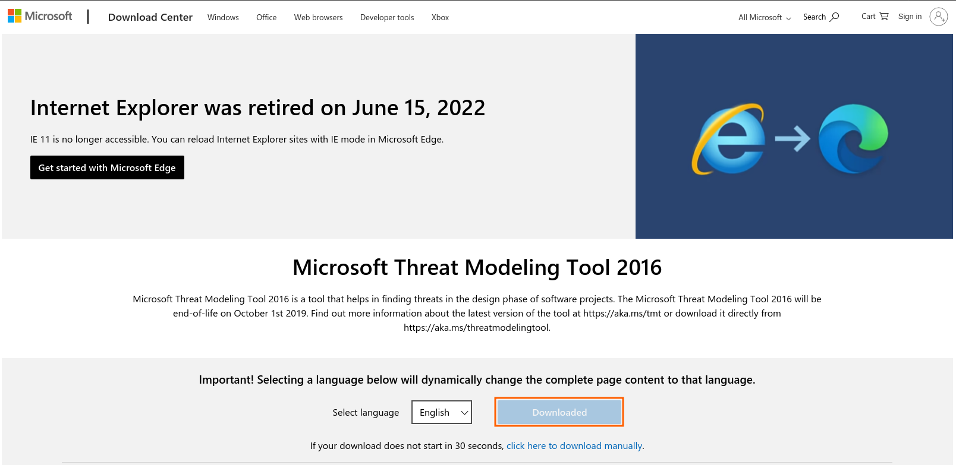



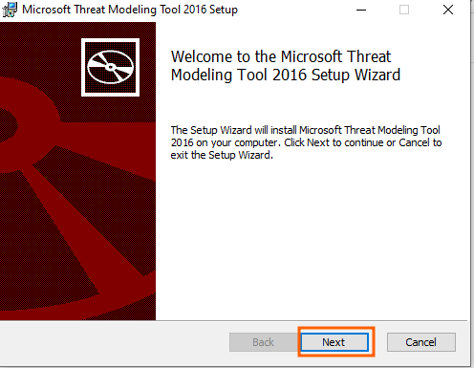

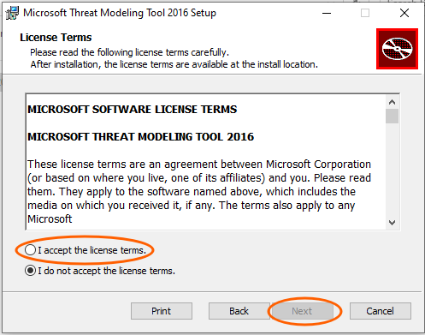

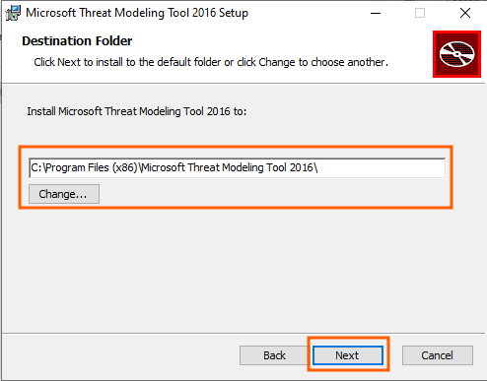

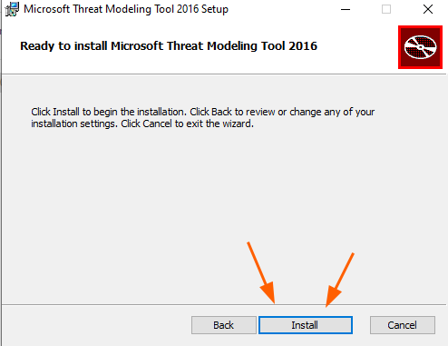

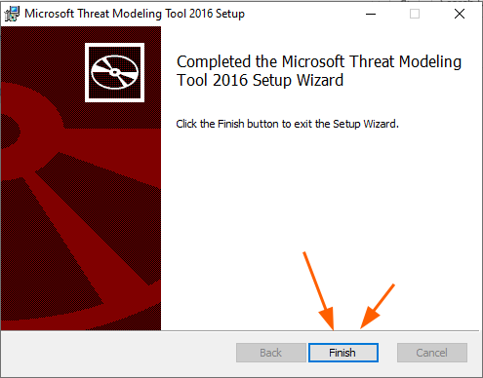

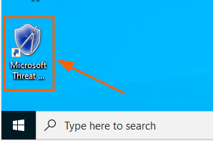

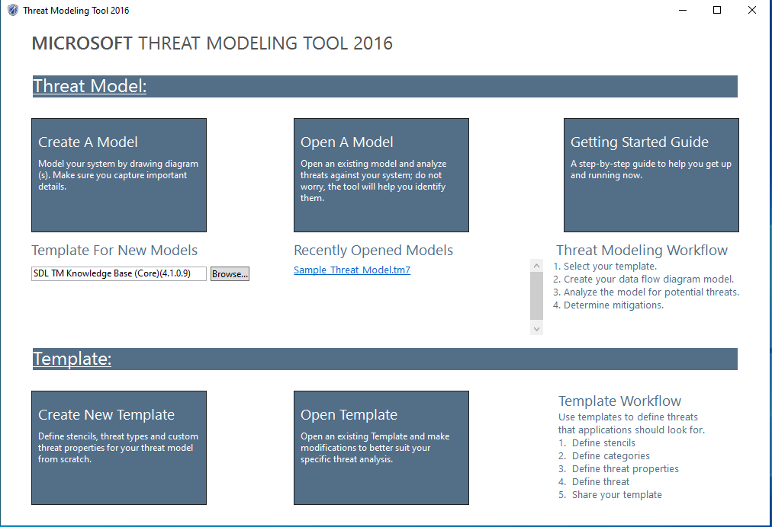

### 

### **Part 2: Threat Modeling**

* Generate a threat model DFD using [Microsoft Threat Modeling Tool](https://docs.microsoft.com/en-us/azure/security/develop/threat-modeling-tool-getting-started). Elements of your DFD will include:

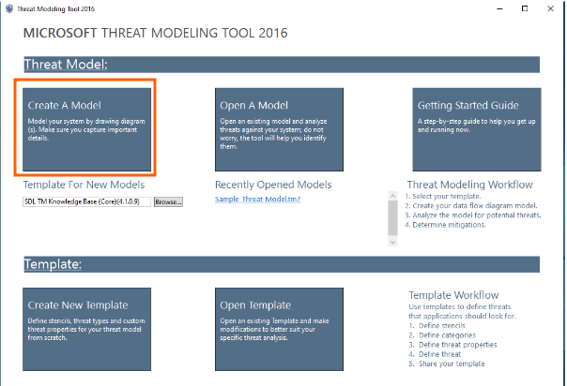

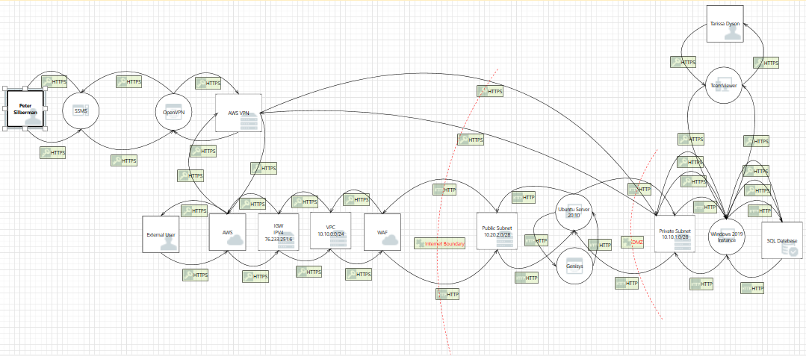

### **Part 3: Communicate Findings**

* Referencing the example in [Template Sample: Web Application Threat Model](https://docs.microsoft.com/en-us/previous-versions/msp-n-p/ff649779(v=pandp.10)?redirectedfrom=MSDN), compose in your submission a full web application threat modeling report. Use DREAD to guide your thought process on what threats are present.
  + Utilize [Template: Web Application Threat Model](https://docs.microsoft.com/en-us/previous-versions/msp-n-p/ff648866(v=pandp.10)?redirectedfrom=MSDN)

When finished, submit both your Web Application Threat Model and DFD in a single Google Doc as indicated below.